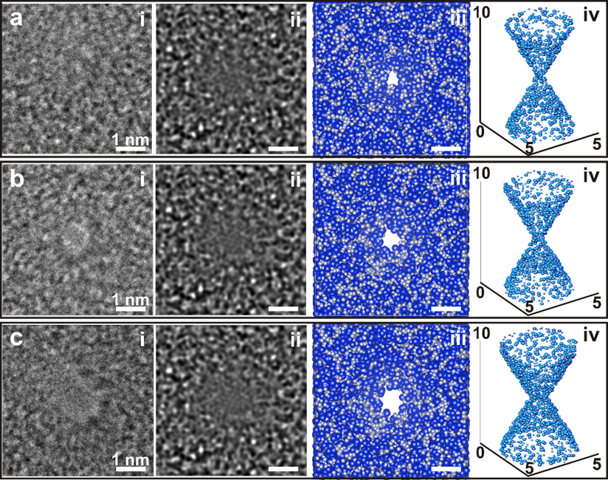

***TEM***

***Simulation***

***Space filling***

**Fabrication subnanopores in 10-nm-thick SiN membranes**

Figure 1 – HOME

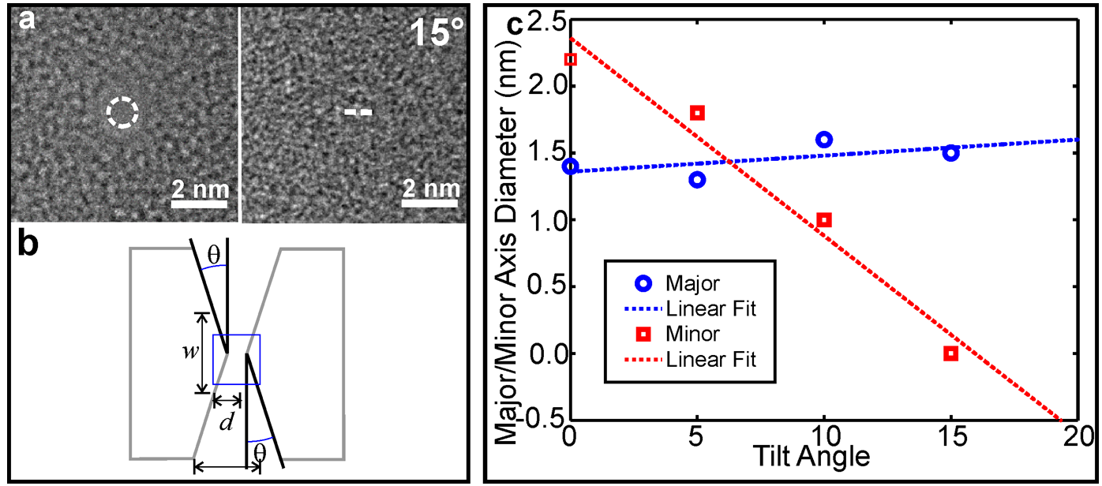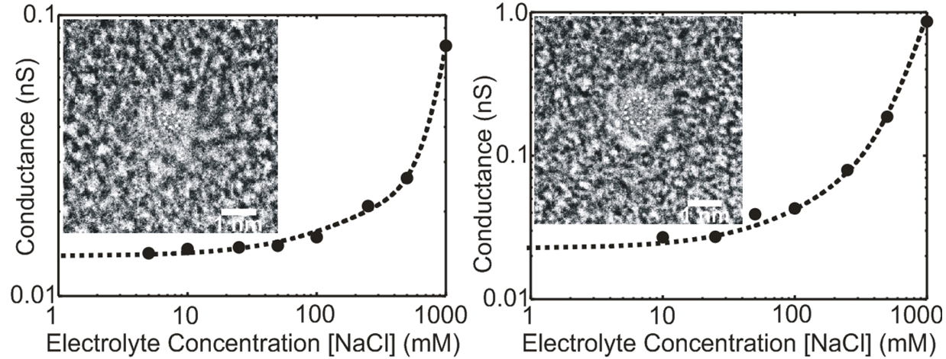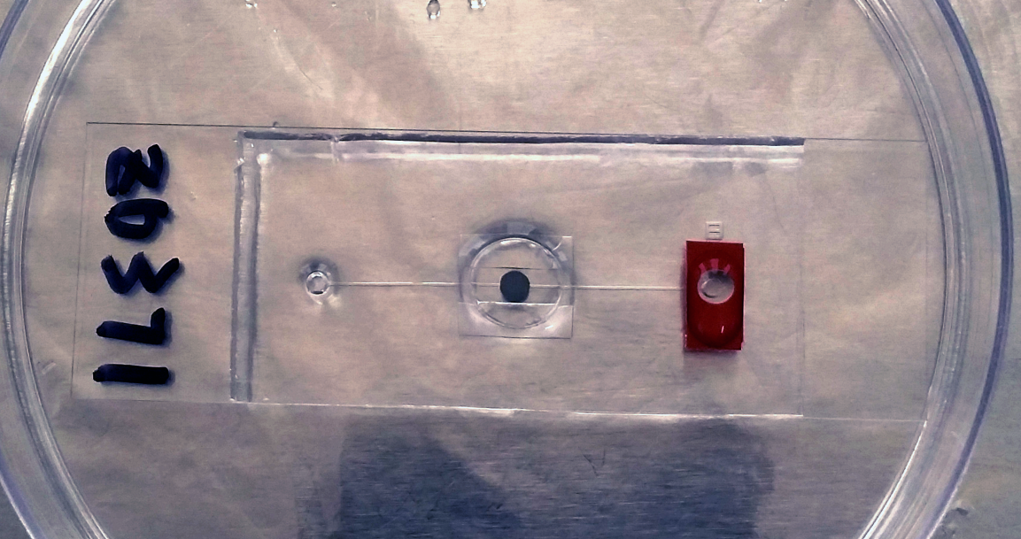

***TEM***

***Tilted***

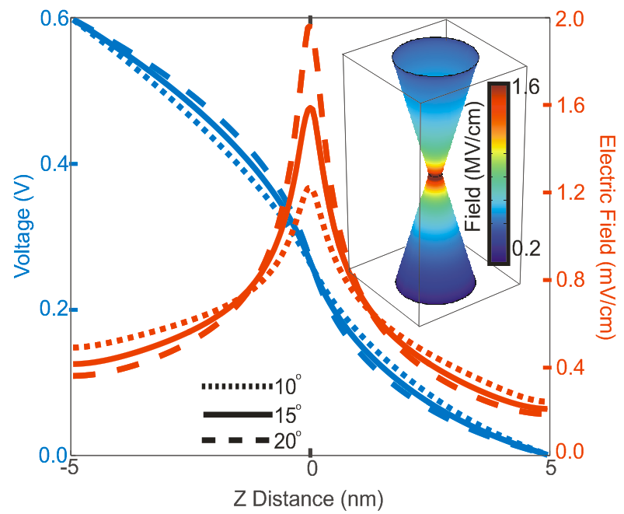

**FWHM=1.5 nm**



**NaCl, 250 mM**

**SiN subnanopores in experiments and simulations**

**TEM**

**σ = 0.016 e/nm2**

Figure 2 – HOME

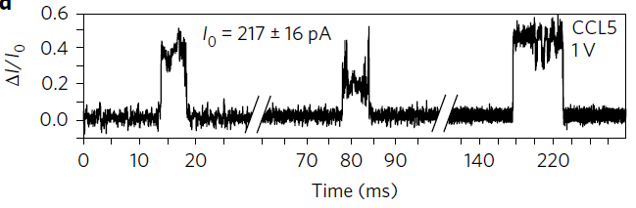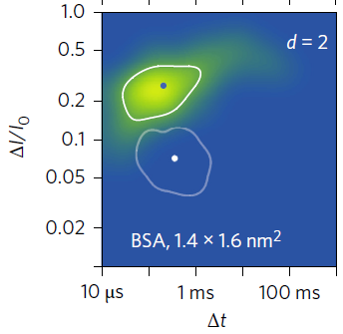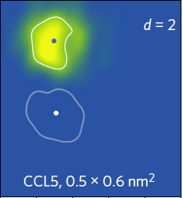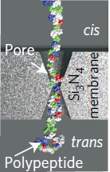

*CCL5, 1.4×1.6 nm2*

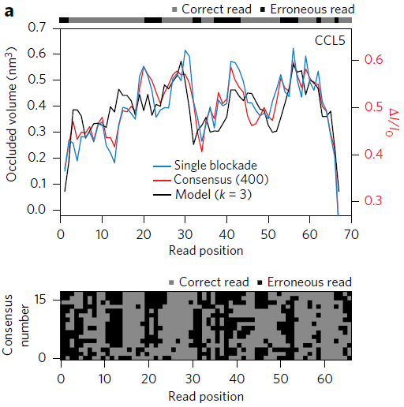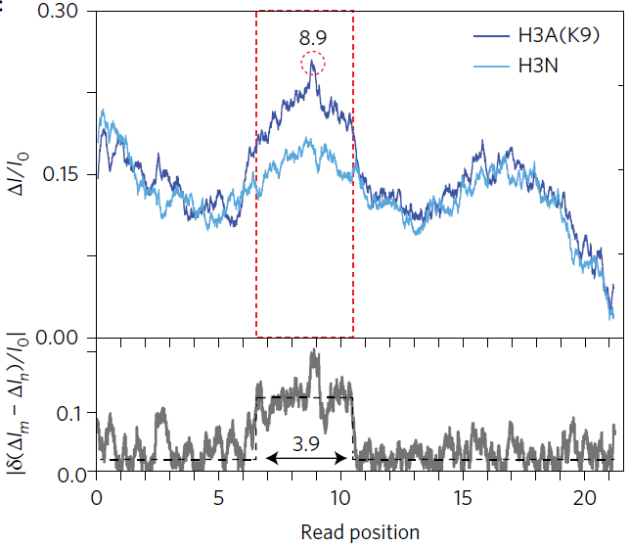

**Read the primary structure of a denatured protein**

**single-site PTM (acetylation)**

Figure 3 – HOME

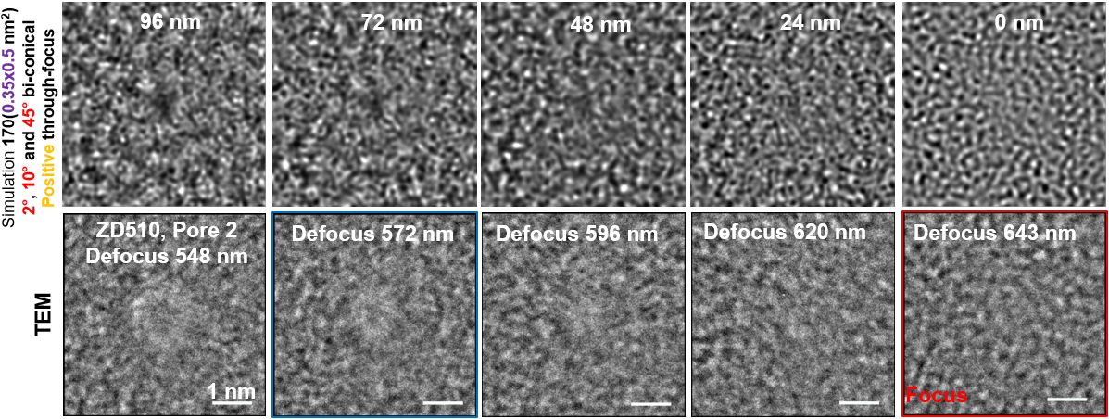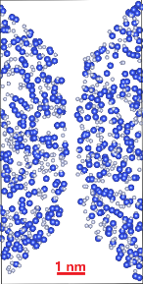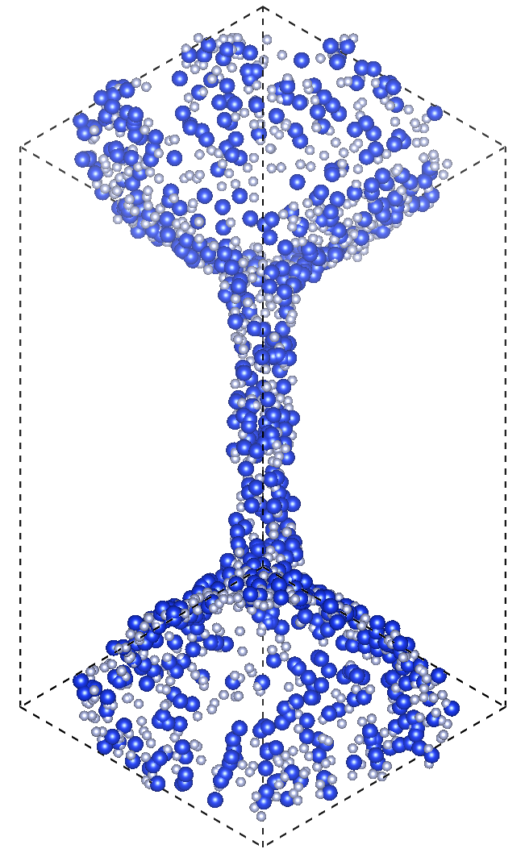

**5×5×10 nm3**

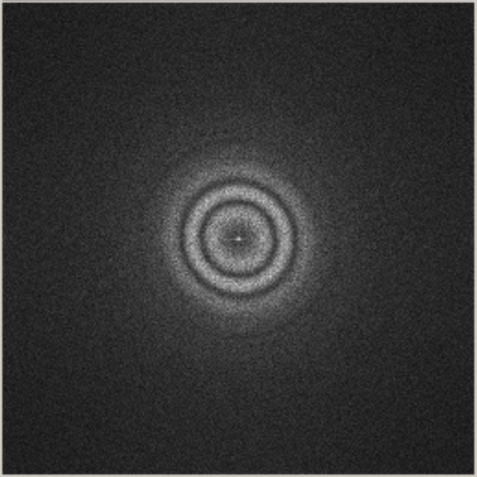

**Live FFT**

Figure 1 – Research